Alumni Newsletter
Department of Physiology and Biophysics
University of Illinois at Chicago
May, 2019

Commencement ceremony

This year marks the 137th Commencement of the College of Medicine. We graduated 12 students in our MSMP (Masters of Science in Medical Physiology) program. This completes our third year of this program. Our graduates this year were:

Mohammed Alrubaee Alexandra Baczynski
Austin Barrett Cory Bockenhauer
Kathryn Buzenius Med Jimson Jimenez
Erik Kozina Nolan Luckett
Bridget Morgan Natalia Pena
Jhunnelle Walters Charles Withington

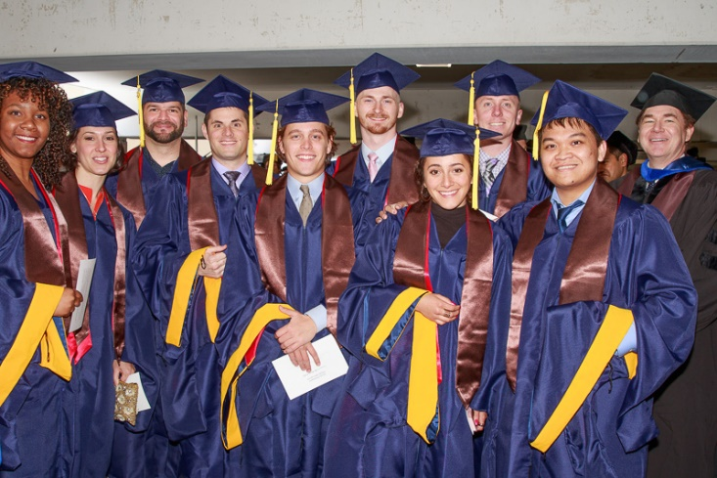

Dr. Mark Brodie who took over the program from Dr. Jesus Garcia is on the right hand side of the picture.

Transitions

Dr. Sergey Popov has retired. He joined our Department in 1994. He will be missed.

Dr. Monica Lee joined our Department in February as an Assistant Professor. Videos of her explaining her work and why she got into science are on our Departmental YouTube channel.

https://www.youtube.com/channel/UCrT9gKNGCPxkP1Xu50kjeig/videos

Students who have defended

Since the last newsletter, two students in the MD/PhD program defended their theses:

March 1, 2019
Alexander Ticho
S-acylation is crucial for ASBT-mediated bile acid uptake: monitoring the transport activity in real time
Advisor: Waddah Alrefai

March 8, 2019
Christopher Manzella
Serotonin is an endogenous regulator of the aryl hydrocarbon receptor in the intestine
Advisor: Ravinder Gill

Department Web page updated

Our revision of the Departmental Web page is finished. Among the many tweaks, our upcoming events and Twitter feed are more prominently displayed on the home page.

